|  |  |
| --- | --- |
|  | Origami |

Group Members:

|  |  |
| --- | --- |
| Student Enrollment | Student Name |
| 1443040 | Malik Muhammad Zarar |
| 1442899 | Ahsan Iqbal |
| 1440831 | Ashar Aiman Qadri |

**Course Code: Prime 2.0**

**Batch Code : 2212B2**

**Semester: CPISM**

**Faculty: Sir Owais Khan**

**Acknowledgments**

We would like to express our sincere gratitude to everyone who has contributed to the successful completion of this project.

Our heartfelt thanks go to **Sir Owais Khan** for providing invaluable guidance and support throughout the entire process.

We are deeply grateful to our colleagues and team members for their hard work, dedication, and collaboration. Their efforts have been instrumental in bringing this project to fruition.

We would also like to thank our families for their love and support, which has allowed us to stay focused and motivated.

Finally, we extend our thanks to all those who have provided us with the resources and opportunities necessary to complete this project.

This project would not have been possible without the help and support of all of you. Thank you.

**Synopsis**

Origami originated from China and was popularized in Japan. It is the art of paper

folding. Paper-folding is a wonderful hobby and a wonderful group activity... and for

kids it has so many benefits socially and for the developing mind. You get to make

cool stuff - with only a sheet of paper!

It&#39;s incredible to watch an ordinary piece of paper transforming into a three

dimensional form, and the more complex the design, the more incredible this process

becomes...

Origami can range from the super complex with realistic models to the simple

models that are more easy to fold, but yet very recognizable.

Here we are aiming to design a website “OrigamiForAll” which will provide an easy

way to learn origami with various designs and steps involved.

**Requirement Specification:**

The Web site is to be created based on the following requirements.

1) The home page must describe the keywords or highlight the origami designs

with all navigation links defined.

2) The site should provide the brief information about origami as from where it

originated etc.

3) There should be a well designed menu with necessary sub menu options.

4) There should be various categories (forms and styles) like easy for kids,

complex for elders.

5) There should also be categories of designs as Faces, animals, birds, flowers

etc. Minimum 10 categories are expected here.

6) Proper description of the design along with the image and steps must be

added in the website.

7) Contact Us

8) About Us

9) Feedback form

10) Gallery section should be added.

11) Color combination must be uniform throughout the project.

12) Navigation must be smooth.

**Site Map:**

Navbar

Logo

Home

Gallery

About us

Contact us

Feedback

**Faces Origami**

**Fish Origami**

Carousel

Categories

Footer

**Airplane Origami**

o

**Boats Origam**i

**Origami for Kids**

**Flower origami**

\

**Birds Origami**

**Checklist of Validations**

|  |  |
| --- | --- |
| Option | Validated |
| Do all text links lead to the appropriate Web pages? | Yes |
| Do all the image links lead to the appropriate Web pages? | Yes |
| Are all the images and links clearly visible on the page? | Yes |
| Is the Web page opening properly in all the tested Web browsers? | Yes |
| Are the animations loading well? | Yes |
| Is the Website responsive? | Yes |
| Is the Website taking too long to load? | No |
| Is the Navigation sequence correct through all the Web pages on the site? | Yes |
| Is the JavaScript code working as expected in all click events? | Yes |

**Task Sheet:**

|  |  |  |  |  |  |  |
| --- | --- | --- | --- | --- | --- | --- |
| **S. No** | **Task** | **Project Title** | **Actual Start Date** | **Actual Days** | **Team Mate Name** | **Status** |
| 1 | Home Page design and coding | Origami | 13-May-2023  22-May-2023 | 9 | Malik Zarar  Ashar Qadri | Complete |
| 2 | Categories | Origami | 23-May-2023  29-May-2023 | 6 | Malik Zarar | Complete |
| 4 | About Us | Origami | 30-May-2023  1-May-2023 | 2 | Ashar Qadri | Complete |
| 6 | Gallery | Origami | 2-June-2023  5-June-2023 | 3 | Ahsan Iqbal | Complete |
| 8 | Contact us | Origami | 6-June-2023  9-June-2023 | 3 | Malik Zarar | Complete |
|  |  |  |  |  |  |  |  |  |  |  | Complete |
| 9 | Feedback | Origami | 10-June-2023  12-June-2023 | 3 | Malik Zarar | Complete |  |  |  |  |  |

**Home:**

**Navbar:**



**Carousel:**





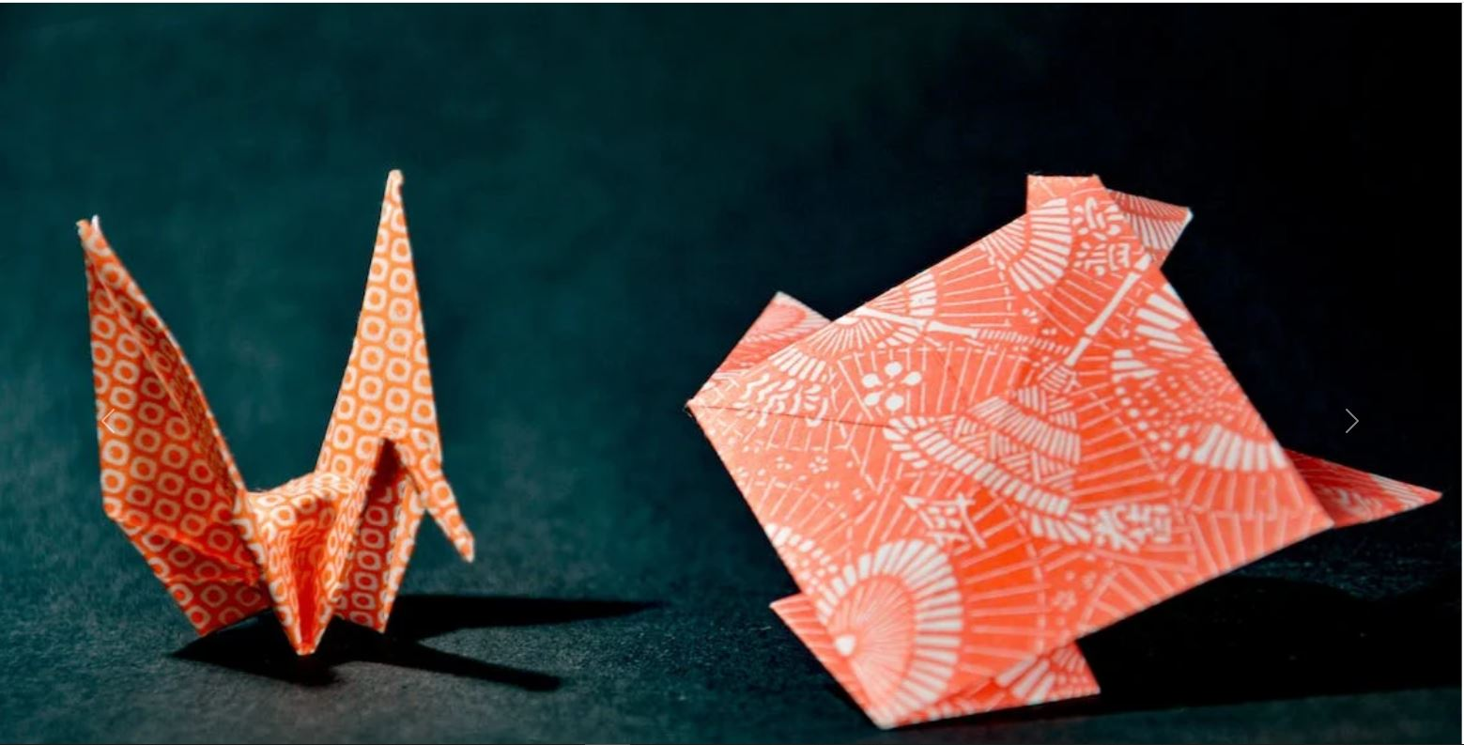



**Categories:**

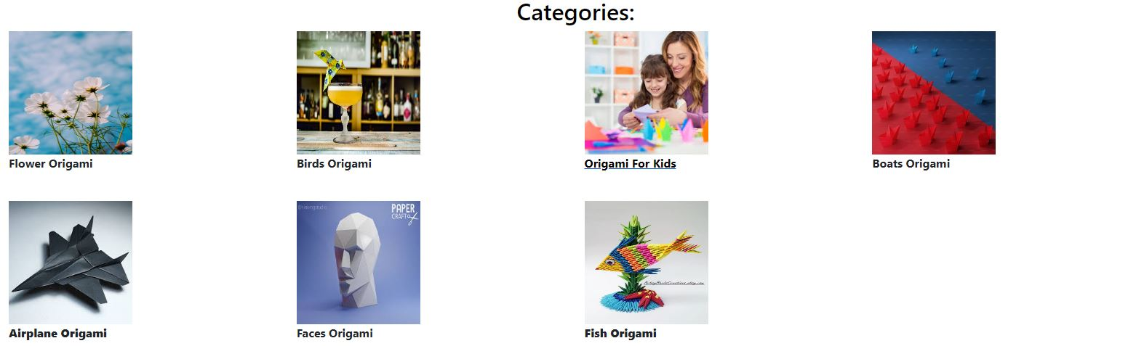

**Footer:**



**Categories:**



